MEET THE SPINE FACULTY
University of Maryland board-certified and fellowship –trained orthopaedic spine surgeon

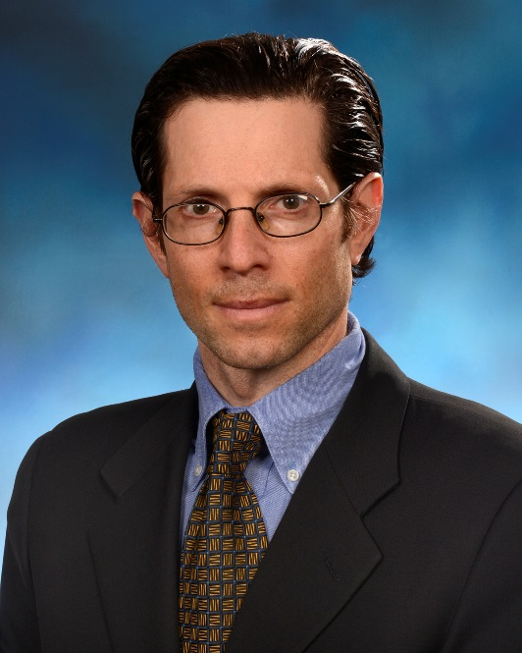
Steven Ludwig, MD

Professor of Orthopaedic Surgery

University of Maryland School of Medicine

Chief, Division of Spine Surgery
University of Maryland Division of Spinal Surgery

Director, Spine Fellowship

University of Maryland Spine Center

Phone: 410-328-3330

Fax: 410-328-0534

Mailing Address:

University of Maryland Orthopaedic & Spine Center

110 S. Paca Street, Floor 6, Suite 300
Baltimore, MD 21201

Dr. Ludwig is an internationally distinguished Academic Orthopaedic Surgeon whose area of expertise include disorders of the cervical and lumbar spine, minimally invasive techniques, sports related injuries, reconstruction of traumatically injured spines and tumor reconstruction. He completed his undergraduate work at Rutgers University, graduating summa cum laude. He received his medical degree at the University of Medicine and Dentistry of New Jersey-Robert Wood Johnson Medical School where he graduated first in his class and served as president of the Alpha Omega Medical Honor Society. He completed his residency in orthopaedics at Thomas Jefferson University Hospital. This was followed by a fellowship in spine surgery at Emory University School of Medicine. He is an active member of the American Academy of Orthopaedic Surgeons, the North American Spine Society, the Cervical Spine Research Society, the Society for Minimally Invasive Spine Surgery, and the Orthopaedic Trauma Association. He is an author of over 100 original articles and 50 book chapter.

